**Wireshark capture steps**

**Step 1: Open Wireshark and look for active network interface**



**Step 2: to generate traffic, ping a server**

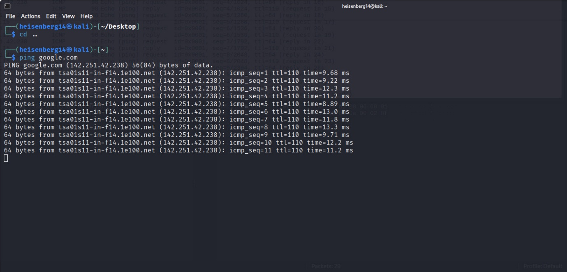

**Step 3: we can also browse a website for further analysis**



**Step 4: analyze the Wireshark capture**

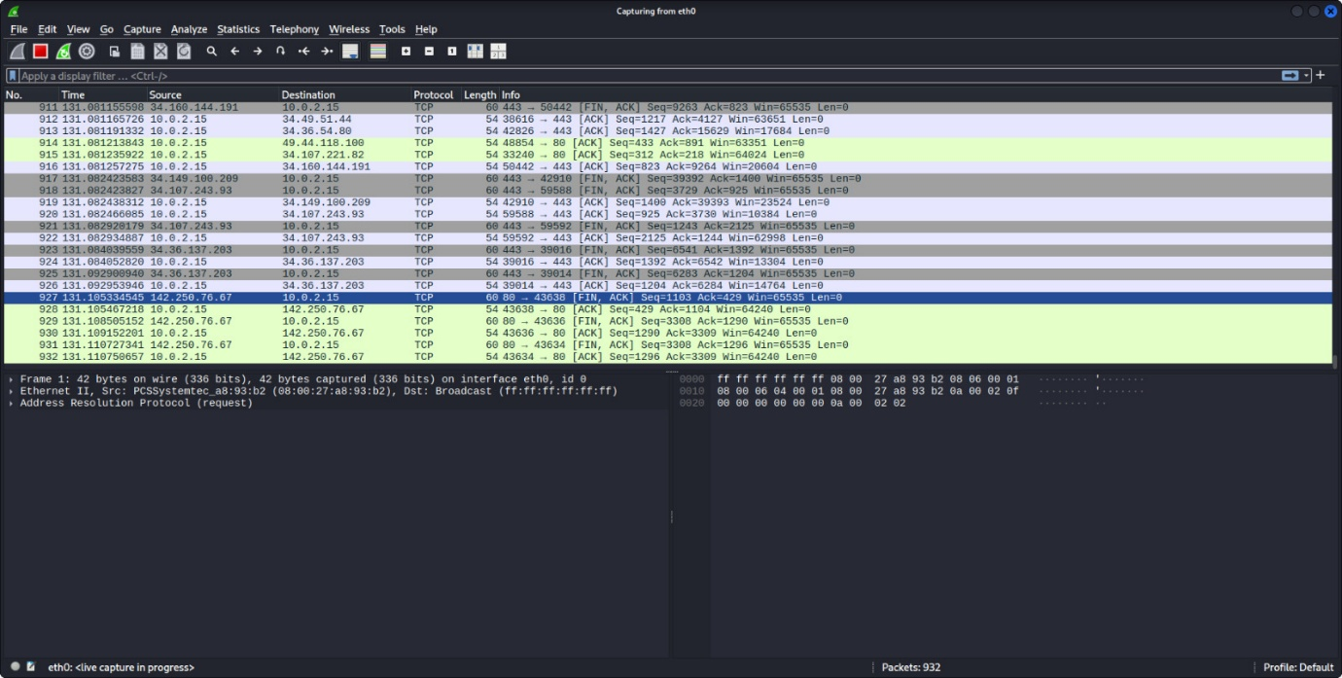

**Step 5: apply HTTP filter**

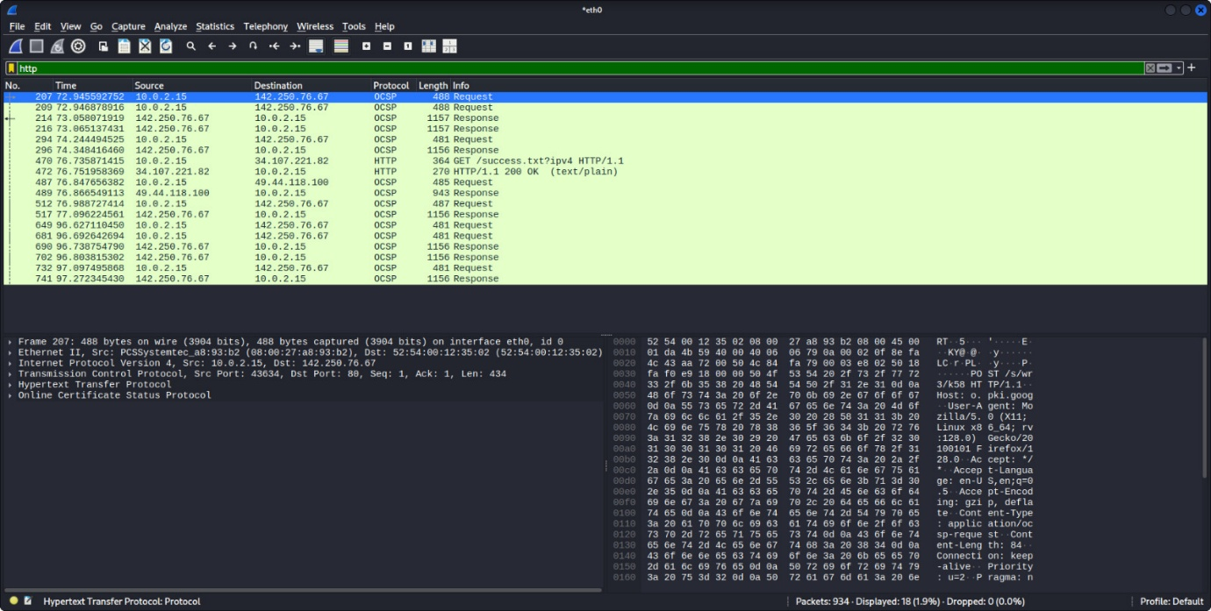

**Step 6: apply DNS filter**

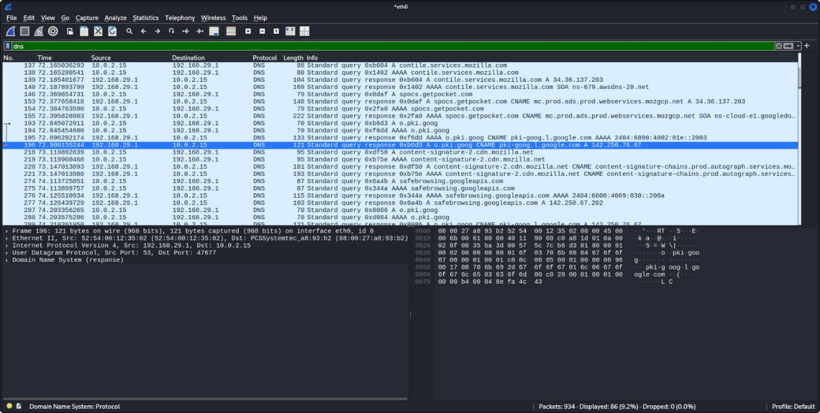

**Step 7: apply TCP filter**

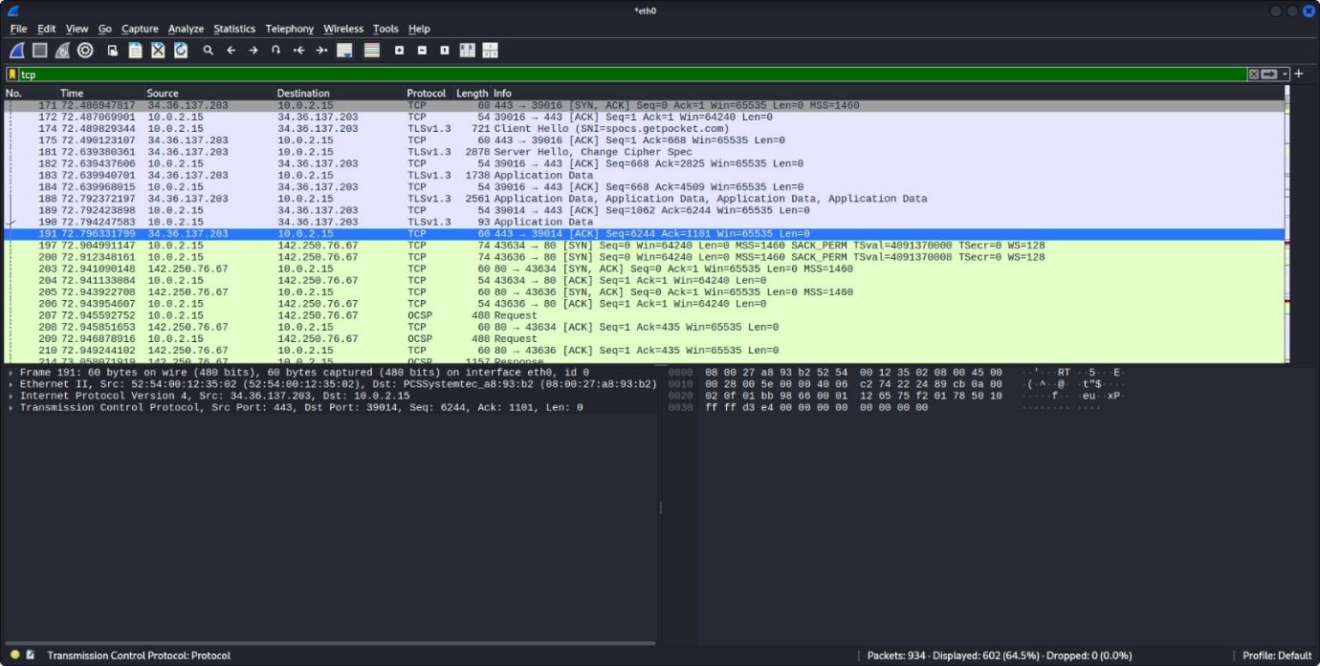

**Step 8: apply UDP filter**

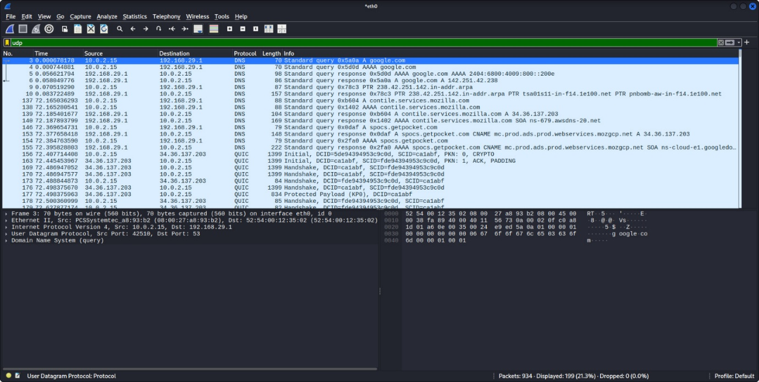

**Step 9: apply ICMP filter**

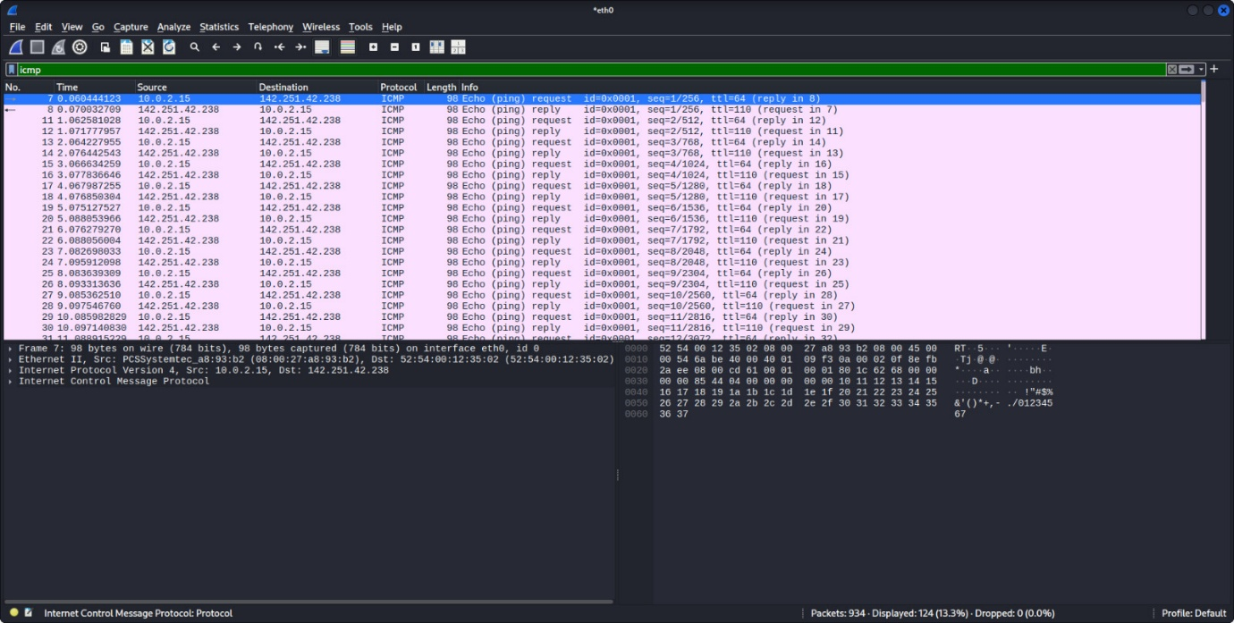

**Step 10: With that we conclude our detailed analysis of Wireshark capture, using various filters.**